**Bluebells: More Than Just a Springtime Bloom**

From a chemical perspective, the vibrant blue pigment in bluebell petals introduces the concept of plant pigmentation and its role in attracting pollinators. This can be linked with discussions on light absorption, reflection, and the role of pigments in photosynthesis.

Bluebells also provide a rich context for studying genetics and evolution. The increasing presence of hybrids between native and Spanish bluebells demonstrates real-world gene flow, natural hybridisation, and the ecological impact of non-native species. This crossover between species raises questions about the long-term survival of true native bluebell populations and offers a case study in genetic variation.

Ecologically, bluebells play an important role as an indicator species. Their presence suggests the woodland has remained undisturbed for centuries, making them a marker for ancient woodland. This ecological connection supports wider discussions on habitats, biodiversity, and conservation. In fact, native bluebells are protected under the Wildlife and Countryside Act 1981, highlighting the importance of preserving natural habitats and native species. Exploring bluebells with students provides a direct link to broader environmental issues, such as human impact on ecosystems, the spread of invasive species, and the importance of protecting natural biodiversity for future generations.

With their stunning violet-blue petals and delicate, drooping bells, bluebells are one of Britain’s most iconic spring flowers. But beyond their visual appeal, bluebells are rich with learning opportunities — especially for science education. Whether you're teaching about plants, ecosystems, or conservation, bluebells offer a tangible, local example of science in action.

Bluebells have adapted to bloom early in the season before the forest canopy thickens, allowing them to maximise sunlight for photosynthesis. Their underground bulbs store energy through the winter, and their deep roots help them survive dry periods and compete with other plants. In terms of reproduction, bluebells propagate both sexually, through seeds, and asexually, by producing offsets from their bulbs—making them a valuable teaching example of different reproductive strategies in plants

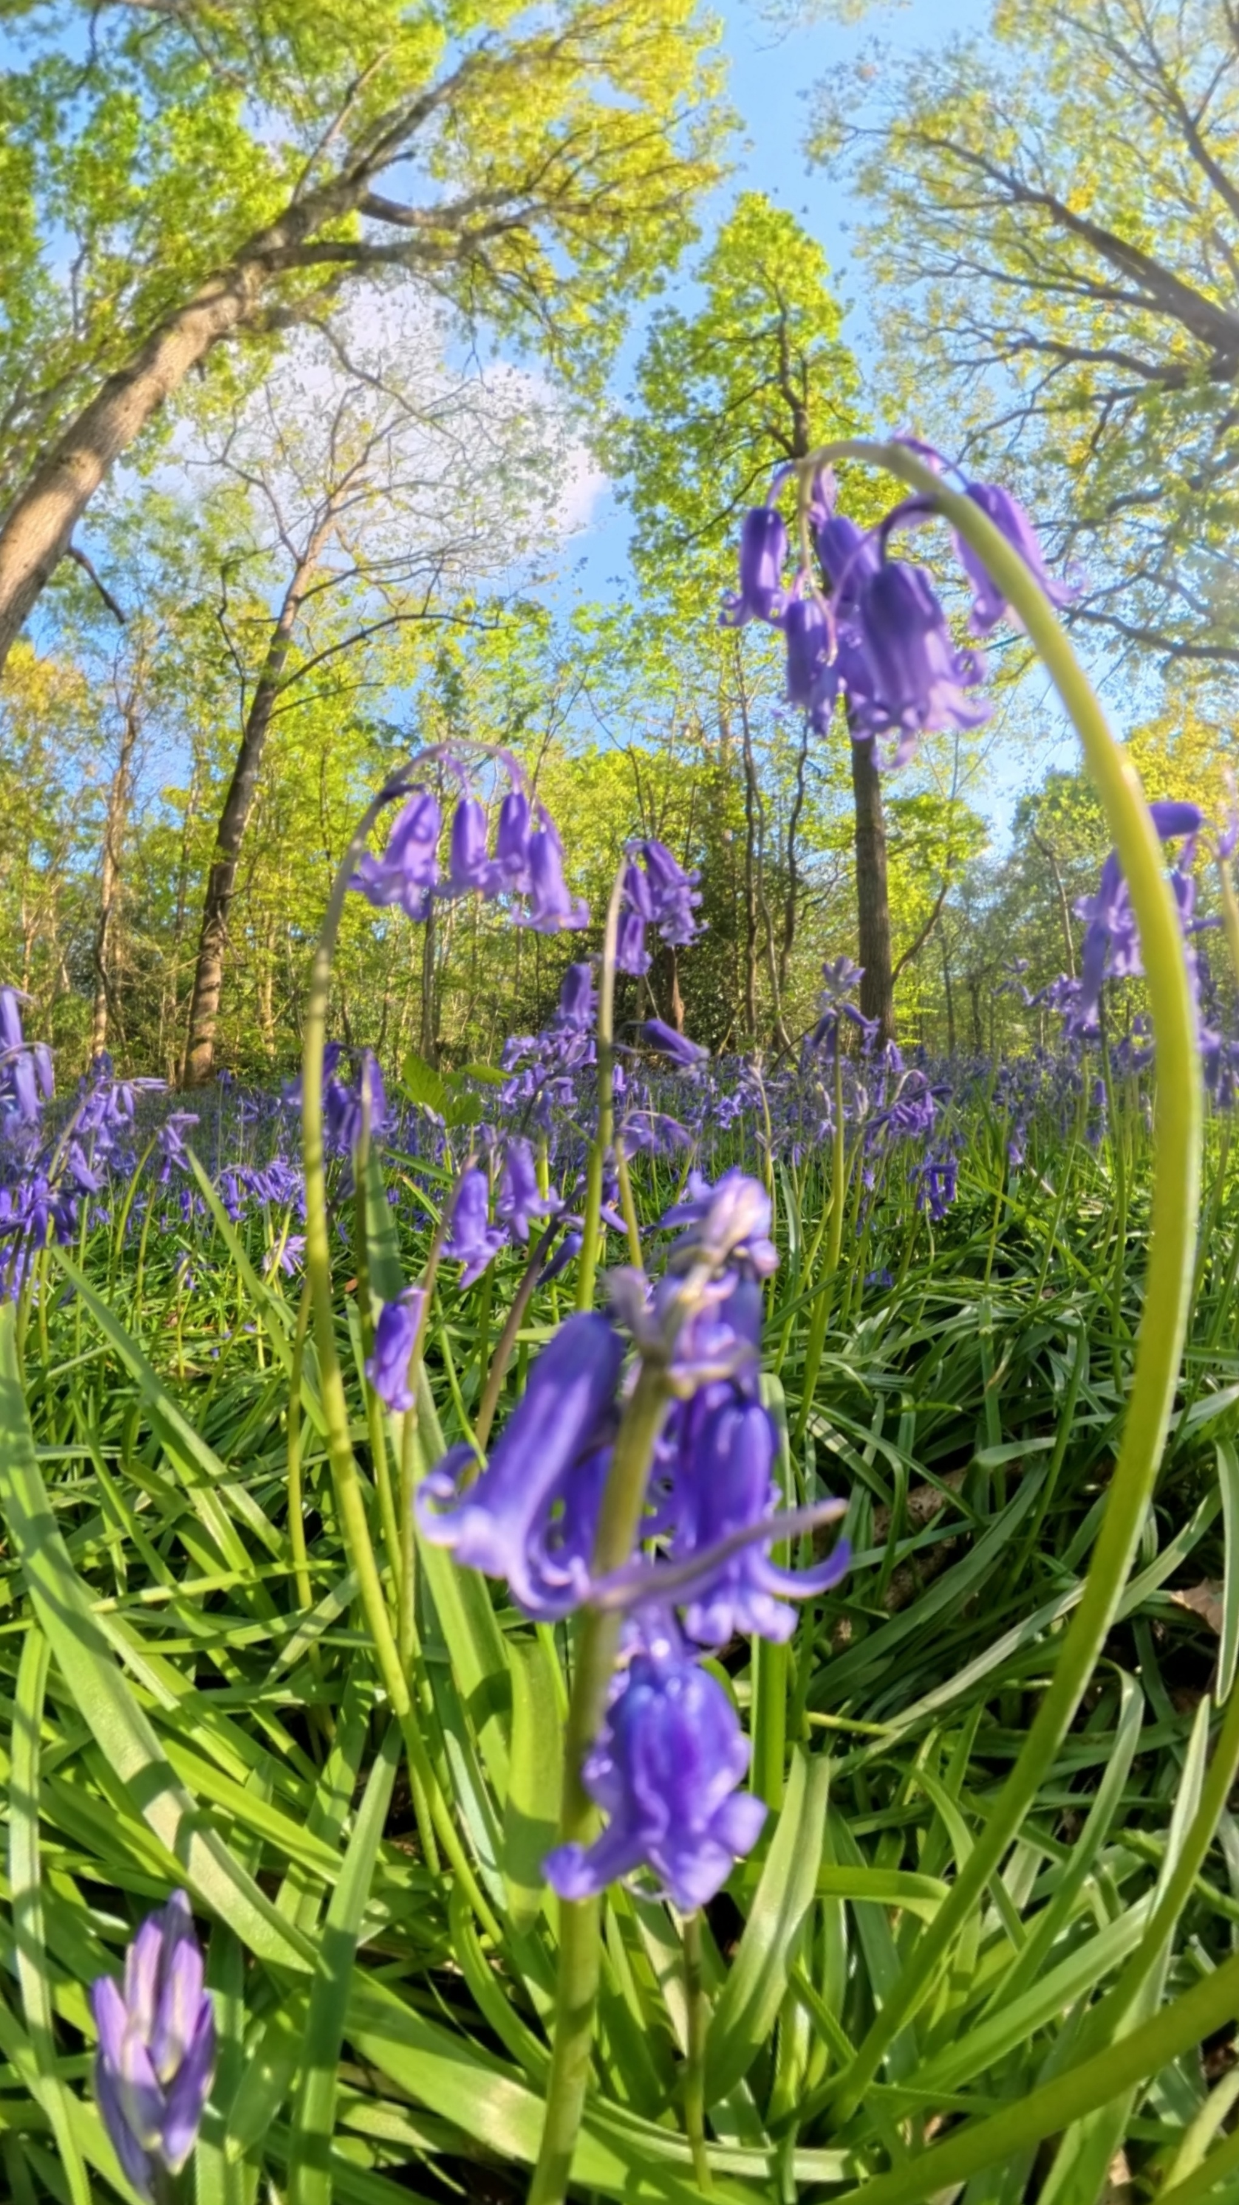

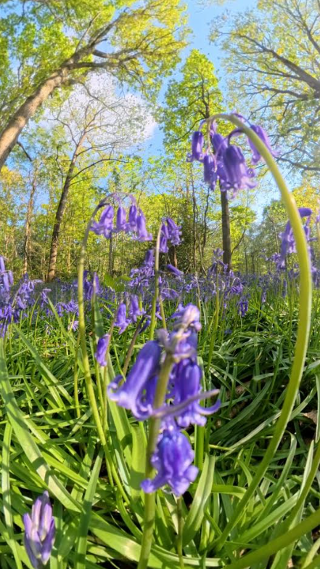

Bluebells in Oxhey woods